Class 6 with substitute: QUIZ 3 + in class writing of HW3: brainstorming and intro from the narrative

REMEMBER: Email (or if you have paper, hand in to the instructor) Career Analysis handout + essay due TODAY.
Make sure your name is on it! Email by 11:59pm! None late!
TODAY’s
QUIZ 3 QUESTIONS
From your reading of (class5 on newclassroom.com ):
https://www.slideshare.net/levi22usa/international-marketing-mistakes-related-to-culture
A)Choose one blunder/mistake and write the company and the problem
B)What type of issue was involved (translation, offensive, ‘sounds like…’, bad endorsement, etc)
C)HOW in 1-2 sentences could this issue have been avoided BEFORE the money/marketing was done

(you can use the same quiz paper or a different one for the in class writing: HW3 below)

Today…IN CLASS:
1)ENG101 HW3 due BRAINSTORMING TECHNIQUES + an INTRO (any style from handout: story, then and now, controversial, etc) for Narrative

For your possible interesting personal narrative event….

1)Choose any one brainstorming technique from list of brainstorming techniques, except for intro type ( #12). List the # [1-15] of the technique you used. On a piece of paper, choose, use and show the work of the brainstorming technique including an experimental paragraph at the end. If you do caption a pic, attach a copy.

2) do 1 INTROS technique FROM INTROS HANDOUT this time for the experience chosen above (should be at least 2-3 sentences minimum; as much as 8-10 – whatever it takes to make it a full paragraph)

3)From these two techniques, Write down/choose the idea you like the best. This will be the topic for the narrative experience you will develop into the Narrative ESSAY, so be choosey.

4)Which of the 10 Universal storytelling tools you think you could use for your narrative event that will help you ‘hook’ a reader audience, and how each of the two brainstorming techniques helped or did not help ‘find’ this.

5)Imagine 2-3 products or services that could match your narrative experience at the end/become endorsed by some significant factor of your experience. Write them down.

For example: If your story was about chasing someone who just stole your laptop, Tool could be FEAR, or maybe humor, and product could be: Nike sneakers, 5 Minute energy drink, HP ultrabook, etc.

10 Universal TOOLS in telling story/choosing topics to hook General audience appeal
(different for each culture, may not translate between different cultures, but every culture has these ‘hooks’ for attention)
1)Universal ‘human’ drama : tragedy, drama, family, loneliness, etc
2)Fantasy roleplay (eg Axe Spray, Sports Videogames)
3)Ride or react to a Trend (eg Vampire genre)
4)FEAR
5)Celebrity or sexual or heroic character’s endorsement
6)Humor
7)Desire to be successful /cool
8)Intensity
9)Disarming of a Fear
10)Over the top or Controversial

When done with HW3, hand in to instructor and may leave for the LC partner class.
Don’t forget the Career Analysis 100 pt assignment is due by tonight 11:59 email or give to instructor!

END

2)BIG ESSAY 2: THE NARRATIVE ESSAY (worth 100 pts): you will write an interesting ‘personal narrative’ 4 pages minimum double spaced about yourself that indirectly advertises a product or service (your choice, real or made up name) with a visual logo or captioned image ) shown at the end

@@@@@

3)All-Purpose (Creative or expository) Writing Steps

I. Prewriting steps including idea brainstorming

II. Brainstorming on Paper

III. starter draft/ zero draft

IV. first draft

V. Revising [for content] drafts

VI. Proofreading [for errors]

VII. Submission draft
After P.A.R.T.S…
After brainstorming....
ZERO DRAFT is…

1)create/collect scenes of 'must haves' for your writing (outline or numbered) as NOTES TO YOURSELF (an ending, an opening, some key actions, images, problems, quotes or feelings or what ifs or dialogue...scattered on a paper, scattered on a computer file, on index cards -- anyway that works for you -- but whatever comes to you as important that this 'story' tells or teaches)

BASICS:
Who is involved in your narrative besides yourself?
■ What event or conflict will you narrate?
■ When and where did the story take place?
■ Why is this story important? What does your audience learn from it?

2) VERY BASIC ORGANIZATION: beginning, middle, end or list in order (outline)

The Beginning
The beginning of your personal narrative should “set the scene.” It does so by introducing
the setting of the narrative (the place and time in which the story occurs), some or all
of the main characters who appear in the story, and the general confl ict or other situation
the story focuses on. The beginning of the story also establishes the tone of the narrative,
whether it is humorous, suspenseful, reflective, peaceful, and so on. The beginning
of a narrative might occupy one paragraph or several, depending on what you want to say about the setting, characters, and conflict.

The Middle
The middle of the story is where the action takes place. Here, the confl ict introduced in
the beginning causes the characters to interact with one another in certain ways. The
middle is the section of the story that leads to the climax—the high point of the story, the
point at which the reader feels the most emotional intensity—through a pattern of rising
action or rising intensity. Often, the climax itself occurs at the end of the middle section
of the narrative.

The End
The end of the narrative is where the meaning of the story is revealed or shown. Usually,
the end is shorter than the other sections. It might be a paragraph in which you
summarize the lesson you learned from the events you’ve narrated. It could even be a
sentence in which you state the “moral” of the story. Sometimes, the climax of the story
happens at the end and the meaning of the events is left to the reader to experience
alone

I. ENG101 Writing: ‘Showing Not Telling’

Guided by brainstorming, or an introduction style, or a mood ( a dominant emotion at the moment of thinking about writing or actual writing, , thinking about a model ad or narrative… You start writing a first draft.

The concerns for a good first draft are:
- putting feelings or memories into relevant scenes;
- using interesting language and images
- making the writing feel real/ connecting with something important within you or your readers (think about the 3 tones for audience appeal)
- making comments or messages directly or indirectly.

not concerns for a first draft:
1) spelling, grammar and punctuation
2) accuracy: correct names and complete researched details
3) handwriting/complete perfect paragraphs
4) symbol systems, image systems, and message levels
5) sparkling non repetitive word use & best scene order
6) filtering scenes and dialog for effectiveness or repetition

I. ENG101 Writing: Always open at least two files at the same time: One for actual writing, one to hold notes to self and ideas OR
use highlighted text for ‘notes to self’
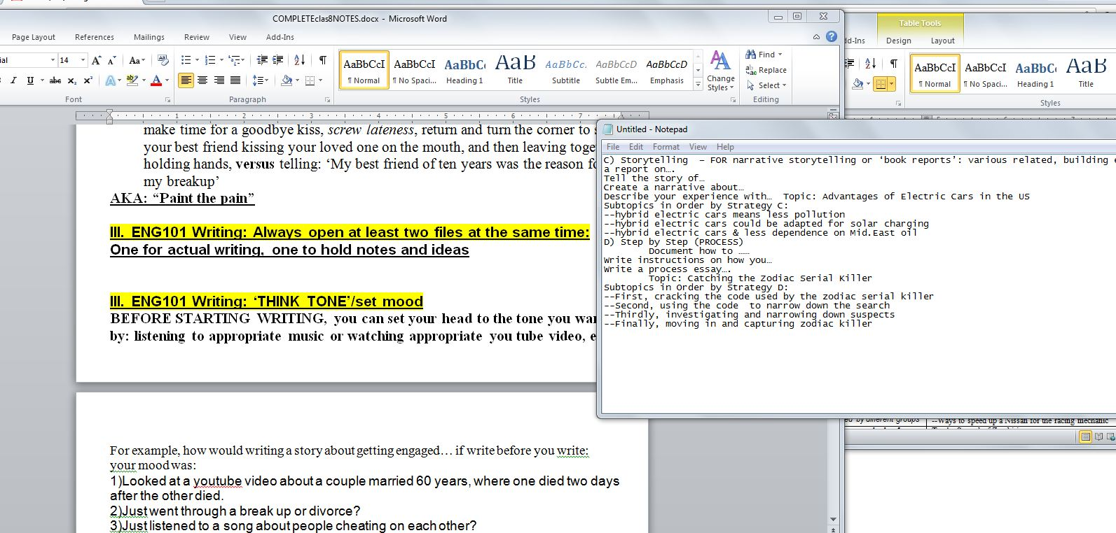

III. ENG101 Writing: ‘THINK TONE’/set and get into the right mood
BEFORE STARTING WRITING, you can set your head to the tone you want by: listening to appropriate music or watching appropriate you tube video, etc.

For example, how would writing a story about getting engaged… if write before you write:
your mood was:
1)Looked at a youtube video about a couple married 60 years, where one died two days after the other died.
2)Just went through a break up or divorce?
3)Just listened to a song about people cheating on each other?

IV. ENG101 Writing: Recovering from a pause or distraction
If you started but had to stop for more than a day or had a major distraction (good news, bad news, responsibility, job, etc) BEFORE STARTING again….
a)Read what you had or notes;
b)Rewrite or retype the last paragraph (small assignment) or last page (medium assignment) or last several pages (large assignment)
[COGNITIVE RE-ALIGNMENT]

I. Remember to ‘show’ to the senses, not just ‘tell’. (describe with sense details as if to someone who can’t see – more dramatic and fills out more, too).
NOTE: Don’t overdo it: ‘the last lonely soggy brown seat on the bus smelled of decomposition and 3 day road kill rabbit killed by a filled to capacity port-o-potty during the Menudo and Tequila festival during stomach virus season, knocked over by high winds, dashed with a hint of end-of-construction-shift armpit, and topped off by the smell of unwashed P.F. Chang Arizona marathon runner’s ass on a 105 degree day with 85% humidity and a barometric dew point of 8.7, after a blitz day of that runner eating at the Menudo and Tequila festival during a full blown attack of the aforementioned in-season stomach virus …’
http://www.bulwer-lytton.com/
ZERO DRAFT STEP 3) Turn scenes into --> Outline or unordered paragraphs or pages okay if out of order

Start a new paragraph in these situations:
1. When the setting or scene changes. If your characters move from one place to another or if one bit of action happens in the morning and the next in the afternoon ( just two examples from many possibilities of change in time), help your reader “see” the change of setting by starting a new paragraph.
2. When the action takes a major step forward. Some narratives contain dramatic
events; others are subtle and might consist more of changes in thinking than of
actual events. Nonetheless, when you feel that your action is moving from one phase
to another, or we jump to another person’s POV, help your reader perceive this change by beginning a new paragraph.
3. When the dialogue switches from one speaker to another. This is a convention of
writing dialogue that you are probably quite familiar with from your personal reading.

WALK THROUGH: Brainstorming to draft:

SAMPLE ESSAY

Developing a ZERO DRAFT:EXAMPLE :
PARTS:

PROBLEM:will write an interesting ‘personal narrative’ 4 pages minimum double spaced about yourself that indirectly advertises a product or service (your choice, real or made up name) with a visual logo or captioned image ) shown at the end

ANALYSIS: FOUR TESTS to see if your possible topic is INTERESTING ENOUGH
--1)Is there an interesting problem? More importantly, is/are there significant complication(s) before the resolution
Despite a missing hand, I play baseball well
--2)look for ways to show conflict and mood. Could it create an emotional response?
YES. Bullying, doubt. Overcoming
---3) Is it interesting to you (Never write something you wouldn’t read)? Which of the 10 Universal storytelling tools are in effect so you know can interest/crossover to general audience? Universal drama, desire to be successful,
10 Universal TOOLS in telling story/choosing topics to hook General audience appeal
(different for each culture, may not translate between different cultures, but every culture has these ‘hooks’ for attention)
1)Universal ‘human’ drama : tragedy, drama, family, loneliness, etc
2)Fantasy roleplay (eg Axe Spray, Sports Videogames)
3)Ride or react to a Trend (eg Vampire genre)
4)FEAR
5)Celebrity or sexual or heroic character’s endorsement
6)Humor
7)Desire to be successful /cool
8)Intensity
9)Disarming of a Fear
10)Over the top or Controversial
--4)VERY IMPORTANT: Can this be written only by you (if the experience can be written generically by almost anyone, won’t work/loses points). Can you tie in to a product somewhere in the story?
Yes – not a lot of people excel at a manual sport without having a hand. Disabled and still a NIKE endorsement.
@@@@@@@

brainstorm,
title: Working title: “Hands ____________”

Random Notes:

being the only shortstop on a baseball team -- without a thumb

If you think that’s tough, my left thumb, check this out,”

I left baseball camp feeling sometimes, giving all you can, still mean going nowhere

If I agreed, a designer hand, custom built and fitted for me, designed for baseball above all things. A team of twenty:

My prosthetic right hand fits the bat the same way everytime

people now look with shock at my .650 batting before they see my hands.

Product? Ott Bock limb? The sponsor, Nike?

ZERO DRAFT: ORGANIZED VERSION
- Beginning: Set the scene

When people discover that I don’t have a thumb on my left hand, the first question they ask is, “How did that happen?” After telling my standard hand in the paper cutter joke to other teenagers or too much thumb-sucking to little kids, I tell them the honest reason for it: a birth defect. Sometimes they ask directly, sometimes you can just see the question in their eyes: how difficult my life must be, being the only shortstop on a baseball team -- without a thumb. I answer, “If you think that’s tough, my left thumb, check this out, no hand”

II. Middle: I am unique but still I fail
I can say I’m unique rather than limited by my missing thumb because of the power of the human body to adapt to its surroundings. I have become quite good at doing different tasks without a thumb. There is absolutely no difference with typing this paper, because only one thumb is needed to press the space bar. I can hold a gallon of milk with my two middle fingers on one side, index finger on one side, and my little finger on the bottom -- something that as a child took me some work to master, but now is a reflex level adaptation. Going to the trombone in Junior High, my friends in band were surprised by how easily I adapted to the trombone by using index and little finger, instead of thumb and little finger, to hold the instrument. Of course I left band behind when I finally got a shot on the sports team.

I tried out at the Nike “Play ball!” Open Call camp, it was clear that I was maxed out not in ability, but in action of what I could physically do. For whatever the reason, maxed out meant I could progress no further and my dreams of baseball as my everything had capped a lot short of sky’s the limit. I left camp feeling sometimes, giving all you can, still mean going nowhere

- ENDING
The only things I can’t do I make up for by improving something else. With the right tools and ambition, how can someone not succeed? I’m proud of myself, but more so that a company (unasked!) saw beyond my disability and sponsored me in the sport that is always in my heart. Taking it to the next level isn’t just a slogan from the commercial. When you see this hand, when you see this logo, know one thing.
No Limits.

“NARRATIVE EXPERIENCE THAT MAKES YOU UNIQUE:” [This is sample FINAL submission draft]

“Eye on the prize, Hand on the Ball” by Kurt Hesse
When people discover that I don’t have a thumb on my left hand, the first question they ask is, “How did that happen?” After telling my standard hand in the paper cutter joke to other teenagers or too much thumb-sucking to little kids, I tell them the honest reason for it: a birth defect. Sometimes they ask directly, sometimes you can just see the question in their eyes: how difficult my life must be, being the only shortstop on a baseball team -- without a thumb. I answer, “If you think that’s tough, my left thumb, check this out,” and then I show them my plastic right hand, and pop it off. The plastic hand creates shock, but that usually changes fast as soon as they see the familiar logo on the prosthetic. “Is that?....”
“It is.”
“Did you have that marked on there yourself?”
“Nope,” I answer. “Logo of my sponsor, and they designed this prosthetic specifically to allow me to play baseball, better. You have the sneakers; I got the hand – very limited edition.” I smile and this usually works as an icebreaker. Growing up, getting into sports in elementary school, at first, I used to feel cast out, different, wishful of just being ordinary. However, with a change of attitude, and a stroke of luck in finding a sponsor that went above and beyond, I usually convince most that actually, my difference is a uniqueness with value, teaching others by example the power of will…with a touch of technology and athlete friendly design, of course.

There are very few team activities which I cannot do because of my thumb or hand. I’m a lefty – whether I wanted to be one or not. The biggest “limit” of not having a thumb or a right hand has always been the minds of coaches, other players, scouts. However, to be honest, using just the standard Ott Bock prosthetic provided by insurance, I too knew I was good at my hobby, but a career in baseball? I’m a realist. I know, can see my limits on the team. This didn’t bother me because I made myself into a pretty good runner, letting teammates do the hands-on work, while I focused on running down people and being able to hit anything farther than most. However, once I tried out at the Nike “Play ball!” Open Call camp, it was clear that I was maxed out not in ability, but in action of what I could physically do. For whatever the reason, maxed out meant I could progress no further and my dreams of baseball as my everything had capped a lot short of sky’s the limit. I left camp feeling sometimes, giving all you can, still mean going nowhere. All those “we will make it through somehow” were Santa Claus lies – well meaning, but ultimately empty things that would not change who I was limited to be. I left camp feeling sorry for myself for the first time in my life. I didn’t play baseball for a month. Why partake if you can’t really win?
That’s when it all happened. That’s when someone from the company saw something in me that I was starting to, myself, disbelieve. That’s when a company known for athlete success decided to invest in me. I was called in, measurements taken, and a project explained to me. If I agreed, a designer hand, custom built and fitted for me, designed for baseball above all things. A team of twenty: engineers, prostheticists, trainers, analysts, and ergonomic/biomechanics experts. Almost a year of work. Twenty rounds of design and fittings. And cost to me? Nothing. Well, maybe my picture on a few ads.
My prosthetic right hand fits the bat the same way everytime. My left hand does take a few seconds more than most to finds a sweet spot, a position where I am able to shift and power the bat through the swing. I can feel the ball’s impact through the bat, through the prosthetic, and learned to take this feedback into training to better my swing, learn brute force how to him better than I ever could. Though at first some of my fellow athletes disbelieved in me and saw only my unique needs as a ‘cheat’ onto the team, eventually I got so good at running and hitting that the victories scored overcame any lingering resentment over changes in strategy and teamwork ideas. If my defense was still a weakness, my consistency at bat made that not matter a bit, or at least worth the risk of having me on the team. One year later: people now look with shock at my .650 batting before they see my hands. Every homerun I hit, I show off the logo on the front of my palm, and the crowd roars. The perfect tools in the hands of an athlete… my hand is that perfect tool.

I can say I’m unique rather than limited by my missing thumb and hand because of the standard ‘feel good’ self-empowerment answers: power of the human body to adapt to its surroundings, power of the will that doesn’t give up. That’s all good and well meaning. But it’s not just about being normal; it’s about being outstanding. Yes, I have become quite good at doing different tasks without a left hand thumb or right hand. Yes, there is absolutely no difference with typing this paper, because only one thumb is needed to press the space bar. I can hold a gallon of milk with my two middle fingers on one side, index finger on one side, and my little finger on the bottom -- something that as a child took me some work to master, but now is a reflex level adaptation. However, getting to the next level: that’s something that spirit can only take you so far. I’m proud of myself, but more so that a company (unasked!) saw beyond my disability and sponsored me in the sport that is always in my heart. Taking it to the next level isn’t just a slogan from the commercial. When you see this hand, when you see this logo, know one thing.
No Limits.
With the right tools and ambition, how can someone not succeed?
My name is Kurt Hesse, Tempe minor league MVP of 2010.

PRODUCT:
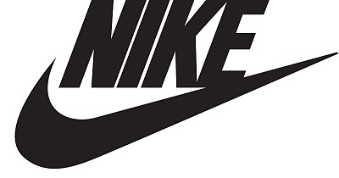JUST DO IT.

GIVE HW 3: DUE THIS THURSDAY 9/14

Narrative Topic NOW due THURSDAY 9/21!

R give whats dinner endangered HW 5

R Thing to remove from draft

R Rubric development: as a class

R HW 5 due

R Group Grade: Pin Worms essay (will narrative be 4 or 3 pg min?)

R Narrative Essay due
END

After brainstorming....
ZERO DRAFT is…

1)create/collect scenes of 'must haves' for your writing (outline or numbered) as NOTES TO YOURSELF (an ending, an opening, some key actions, images, problems, quotes or feelings or what ifs or dialogue...scattered on a paper, scattered on a computer file, on index cards -- anyway that works for you -- but whatever comes to you as important that this 'story' tells or teaches)

BASICS:
Who is involved in your narrative besides yourself?
■ What event or conflict will you narrate?
■ When and where did the story take place?
■ Why is this story important? What does your audience learn from it?

2) VERY BASIC ORGANIZATION: beginning, middle, end

The Beginning
The beginning of your personal narrative should “set the scene.” It does so by introducing
the setting of the narrative (the place and time in which the story occurs), some or all
of the main characters who appear in the story, and the general confl ict or other situation
the story focuses on. The beginning of the story also establishes the tone of the narrative,
whether it is humorous, suspenseful, reflective, peaceful, and so on. The beginning
of a narrative might occupy one paragraph or several, depending on what you want to say about the setting, characters, and conflict.

The Middle
The middle of the story is where the action takes place. Here, the confl ict introduced in
the beginning causes the characters to interact with one another in certain ways. The
middle is the section of the story that leads to the climax—the high point of the story, the
point at which the reader feels the most emotional intensity—through a pattern of rising
action or rising intensity. Often, the climax itself occurs at the end of the middle section
of the narrative.

The End
The end of the narrative is where the meaning of the story is revealed or shown. Usually,
the end is shorter than the other sections. It might be a paragraph in which you
summarize the lesson you learned from the events you’ve narrated. It could even be a
sentence in which you state the “moral” of the story. Sometimes, the climax of the story
happens at the end and the meaning of the events is left to the reader to experience
alone

SAMPLE ESSAY

Developing a ZERO DRAFT:EXAMPLE :
Audience: General (personal example/interesting case).
Purpose: The unusual, nonsense crap that has to happen to keep or tear a family apart.
Tone: Childhood crimes, maybe deep secrets kept, tragedy and recovery? (Looking at a picture from the old home in Flagstaff – had so much but no one in pic happy except me as kid.)

brainstorm, started with method 15) personal experience summarized w/ notes
(no particular order): Working title: “Family fires”
(
Waking up in the middle of the night, smelling smoke
Introduce the home in Flagstaff
Introduce Mom and Dad
Losing Everything
Mom buying a smoke detector; Dad refusing to install it
Three days later parents announced divorce.
Hearing a pop, jumping out of bed, running downstairs
How the fire started (don’t tell audience)
Set the scene: checking the laundry, going to bed: Dad Laundry at night, leaving tomorrow.
C. Seeing smoke and fire in the living room
Yelling to wake Mom and Dad
They cancel divorce

Product? Lie Detector, fire alarm, “Save the Family” campaign, book on divorce

ZERO DRAFT STEP 3) Turn scenes into --> Outline or unordered paragraphs or pages okay if out of order

Start a new paragraph in these situations:
1. When the setting or scene changes. If your characters move from one place to another or if one bit of action happens in the morning and the next in the afternoon ( just two examples from many possibilities of change in time), help your reader “see” the change of setting by starting a new paragraph.
2. When the action takes a major step forward. Some narratives contain dramatic
events; others are subtle and might consist more of changes in thinking than of
actual events. Nonetheless, when you feel that your action is moving from one phase
to another, or we jump to another person’s POV, help your reader perceive this change by beginning a new paragraph.
3. When the dialogue switches from one speaker to another. This is a convention of
writing dialogue that you are probably quite familiar with from your personal reading.

ORGANIZED VERSION
I. Beginning: Set the scene
A. Introduce the home in Flagstaff
B. Mom buying a smoke detector; Dad refusing to install it
C. Three days later parents announced divorce.
D. Living there
E. Introduce Mom and Dad
F. Set the scene: checking the laundry, going to bed: Dad Laundry at night, leaving tomorrow.
II. Middle: The story of the fire
A. Waking up in the middle of the night, smelling smoke
B. Hearing a pop, jumping out of bed, running downstairs
C. Seeing smoke and fire in the living room
E. Yelling to wake Mom and Dad
F. Losing Everything
III. End: What we learned
A. How the fire started (don’t tell audience, let them try to figure out if me, dad started it, ‘Angels’)
B. Parents Cancel divorce
C. Final sentence????

PRODUCT: Book: “Clean Break: Preventing Children from acting out when divorcing under hostile conditions”

ZERO DRAFT STEP 4) Order your notes/scenes to match the parts of your organization of subtopics or timeline or sections or type, cut and paste the segments around into a single document

ONE SINGLE NOTEBOOK… starts writing intros / 3 types of intros….

What is a fire?
A family fire is….

Flat intro: My family home in Flagstaff burned down on ZZZZZZZZz, three days after my father and mother sat down and told me that they (dad said ‘SHE’) decided a divorce was best. We survived the physical fire as a family, with just our night clothes. We survived the family fire much better after that, as if the announcement for divorce had never happened and all the dead weight we carried burnt off our backs so we could stand again, united as a family.
SELF NOTE: [did not use – WHY? Not sure where to take it – it’s almost already done as a story)

Original controversial intro: They say a forest fire clears dead wood so new plants can grow, right? When all the good are asleep and dreaming, sometimes angels or devils sometimes listen in, maybe grant wishes, even pyro a place to the ground, when they are asked honestly, with feeling – asked to intervene and save something that matters but is about to shatter .

Controversial intro revised v2: I said to nobody, meaning to everybody in the Universe above my bed, on one long dark night of solitary tears, that I would give up every video game, every DVD, every bit of favorite clothing if I could keep my family intact. A day after a blowout over how much money my mom spent on paranoia house safety purchases, my dad throwing a firealarm against the outside of the house -- I knew we were almost done. Three days later we had the family ‘talk,’ and two days after that I caught my dad doing a last night of laundry before his planned date for moving out. It was all real now.

When all the good are asleep and dreaming, sometimes angels and devils sometimes listen in, maybe even would pyro a place to the ground, when they are asked honestly, with feeling – asked to intervene and save something that matters but is about to shatter .
SELF NOTE: Maybe ending with this?
They say a forest fire clears dead wood so new plants can grow. We survived better than before: even though the fire insurance would not pay us fully, we move away from Flagstaff together, eventually got back on our feet, and everyone then remembered the part of “Til death us do part” from then on. I got to keep both father and mother. Those are the only things I really needed, really.

SELF NOTE: [did not use – WHY? TONE: psychopath. Don’t want classmates to think I’m a psychopath )

Story intro Version 1:
I was dropped off a few minutes early by the after-school-mom third-grade carpool. At the driveway in front of my house in Flagstaff, my family was again floorshow for my neighbors and friends. My mother yelling at my father, “because you are so a selfish desperate prick and I know you, that’s why,” and my father holding a small round bomb-looking thing with a flashing green light. They saw us arrive and my mother went into Disney mode and said, “Honey, boys, Camilla, you are back early…snacks?…for you and your friends, want to come in?” Eyes are glassy-watery and her face red from the argument blood gathered in her cheeks before she shrugged in fear at the next sound, under her mask of mom-greets-carpool. A loud broken crash of my dad’s perfect pitch of the round object against the house as I get out of the car and close the door behind it. Dad rushes into the home, appearances who cares; while the smoke alarm dies a single auto-check alarm before settling, broken up, behind the Charcoal BBQ grill on the patio.

“Darn machines don’t work sometimes even with the instructions, and my husband, he gets frustrated,” Mom excused pops pathetically. “Snacks? I have cupcakes.”

“No thanks…others to deliver, see you,” answers Camilla in a shaky rushed voice clutching the steering wheel with fear. Everyone knows not to get involved. Disney mode continues – mom’s pat to the head and hand on my shoulder. Fires don’t fan in public places in my household. At least not without a little help.
NOTE TO SELF: Don’t use – last sentence tells everyone I set the fire. spoiler alert.

Story intro Version 2:
Dropped off a few minutes early by the after school mom carpool, at the driveway in front of my house in Flagstaff, my family was again a floorshow for my neighbors and friends. My mother yelling at my father, “So selfish, cheap -- you would put a price on our safety?!?” and my father holding a small round bomb-looking thing with a flashing green light. They saw us arrive and my mother went into Disney mode and said, “Honey, boys, Camilla, you are back early…snacks?… want to come in?” A loud shatter-smash sound -- my dad’s perfect pitch of the round object against the patio a few feet in front of him as I get out of the car and close the door behind me. Dad rushed into the home, yelling to no one in particular, the cheap alarms are good enough—don’t want to waste my money – your lawyer will do that for you anyway!” The smoke alarm did an auto-check alarm as it lay in its own pieces of broken plastic, behind the BBQ Weber Grill, on the patio.

“No thanks…others to deliver, see you,” answers Camilla in a shaky rushed voice clutching the steering wheel with fear. Everyone knows not to get involved. My mom’s Disney mode continues – mom pats my head and ushered me inside. Fires don’t fan in public places in my household.

TIRED, MAKES CLOSING NOTES TO SELF/REMINDERS before stopping for today:
[rest of story: A few days later, wake up in the middle of the night, smelling smoke. ]

Loud pop – half broken fire alarm left on porch still activating and then ringing out, pop and echo against the Weber Grill: damaged alarm tone, but still loud enough to awaken me and anyone within a mile.

Fire in the living room

I wake up all, scream out

Alarm, though damaged from throw, would keep going off so loud that neighbors heard almost a ¼ mile away and called fire department while we made it out somehow with bedding mattress out of window – father being a father and a hero before he, bloodied from glass and effort barely makes it out before fire hits the roof we just slid down out of window, carrying a few things, especially??????

NOTES TO SELF: A LESS PSYCHO ENDING NEXT:
The fire insurance wouldn’t pay because the alarm was not installed IN THE HOUSE.
Even as parts of the burning porch fell on the alarm, it kept going.
We lost so much, but regrouped and found what was really important had survived.
We are still a family
We are still alive

Product at the end? (not a child’s mental hospital outreach)
First Alert Firealarm -- survived the throw at a tree!
Loudest, toughest alarms.
“American built to military standards, but sold for American safety.”

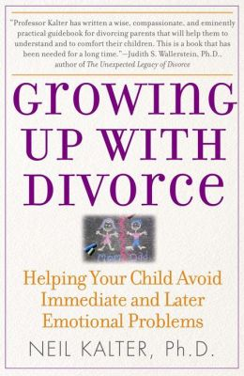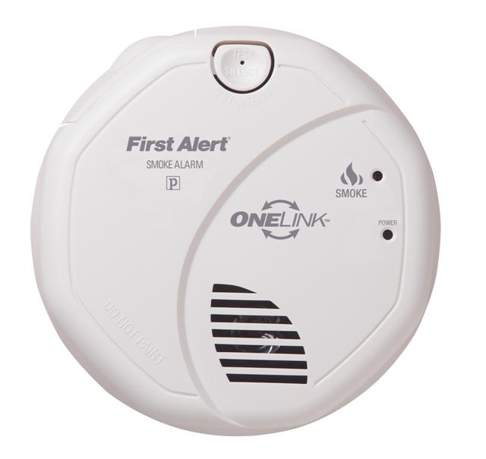

III. So how will it be graded: what is a rubric? Let’s give out the points!
Split Out of 70 pts…(grammar and sentences and paragraph = 30 pts)

FINAL VERSION OF AGREED UPON RUBRIC FOR NARRATIVE ESSAY:
Narrative Essay Out of 100 pts (Negotiated) | LAST YEAR’S Narrative Essay
1. Topic Appropriate ____ | 1. Topic Appropriate [0-5]
2. Essay delivers its message/stays on topic ____ | 2. Essay delivers its message/stays on topic [0-10]
4. Creative/uncommon [] ____ | 4. Creative/uncommon [0-5]
5. Detailed/specific content/ enough ex. _____ | 5. Detailed/specific content/ enough ex. [0-10]
6. Essay breaks down into relevant para. _____ | 6. Essay breaks down into relevant para. [0-5]
7. Strength of imagery _____ | 7. Strength of argument or Strength of imagery [0-5]
8. Grammar & Spelling _15pts | 8. Grammar & Spelling [0-15]
9. Sentences& Para. 15 pts | 9. Sentences & Para. [0-15]
10. Format _____ | 10. Format [0-5]
11. Consistent/Builds _____ | 11. Consistent/Builds [0-5]
12. LENGTH (double spaced, Name, date at top)  < 2.5 pages = 0/F  Between 2.5 pages and bottom of page 2= -20  Hits 3rd page but < middle = -10  Hits middle of 3rd page but not to bottom= -5 | NOT NEGOTIABLE
13. Cohesive/Sounds Good /____ | 13. Cohesive/Sounds Good [0-10]
15. Introduction _____ | 15. Introduction [0-5]
16. Conclusion _____ | 16. Conclusion [0-5]
Last year NARRATIVE: 10 A’s, 7 B’s, 3 C’s, 3 F (all were too short), 2 drops

For next class: Improving DRAFTS. NO QUIZ or HW, just class! Good luck on GBS exam!

MAKE SURE TO HAND IN ANALYSIS/CAREER BREAKDOWN at end of class OR email NO LATER THAN 11:59pm (make sure you get email reply saying received!) LATE = 0 of 100/F!!!
Miguel.fernandez@cgc.edu AND BACKUP eng102papers@gmail.com
SAME FOR HW4!!!!

