NO QUIZ TODAY

FOR TUES NEXT CLASS:
Quiz #4: “For 9/18 T READ: “Facebook users ask who owns Information” 97-100
Hand in HW 5 (will be given out today)

START WRITING!: NARRATIVE ESSAY submission final draft: due 9/26 (fourteen days!)

All-Purpose (Creative or expository) Writing Steps

I. Prewriting steps including idea brainstorming

II. Brainstorming on Paper

III. starter draft/ zero draft (semi organized notes, some paragraphs)

IV. first draft (actual writing) TODAY

V. Revising [for content] drafts, transitions + sample grading

VI. Proofreading [how to, for errors]

VII. Group activity: Grade for extra credit

VII. Narrative Submission final draft due THURS 9/26

III. HAND OUT FINAL VERSION OF THE RUBRIC

I. ENG101 Writing: ‘Showing Not Telling’

Guided by brainstorming, or an introduction style, or a mood ( a dominant emotion at the moment of thinking about writing or actual writing, , thinking about a model ad or narrative… You start writing a first draft.

The concerns for a good first draft are:
- putting feelings or memories into relevant scenes;
- using interesting language and images
- making the writing feel real/ connecting with something important within you or your readers (think about the 3 tones for audience appeal)
- making comments or messages directly or indirectly.

not concerns for a first draft:
1) spelling, grammar and punctuation
2) accuracy: correct names and complete researched details
3) handwriting/complete perfect paragraphs
4) symbol systems, image systems, and message levels
5) sparkling non repetitive word use & best scene order
6) filtering scenes and dialog for effectiveness or repetition

The basic advice to meet these four concerns given to writers is to show, not tell, what happens.
For example, write a narrative when you were betrayed by a friend
TELLING/SAYING/writing: “My best friend of ten years was the reason for my breakup”
INSTEAD, An example of the power of showing rather than telling:
You write a scene that has friendly dialogue about how happy you are with your current loved one and a friend at a hangout, then you draw the scene where you leave in an extreme hurry, pause/reconsider/ turn around/decide to make time for a goodbye kiss, screw lateness, return and turn the corner to see your best friend kissing your loved one on the mouth, and then leaving together holding hands, versus telling: ‘My best friend of ten years was the reason for my breakup’
AKA: “Paint the pain”

I. ENG101 Writing: Always open at least two files at the same time: One for actual writing, one to hold notes to self and ideas OR
use highlighted text for ‘notes to self’
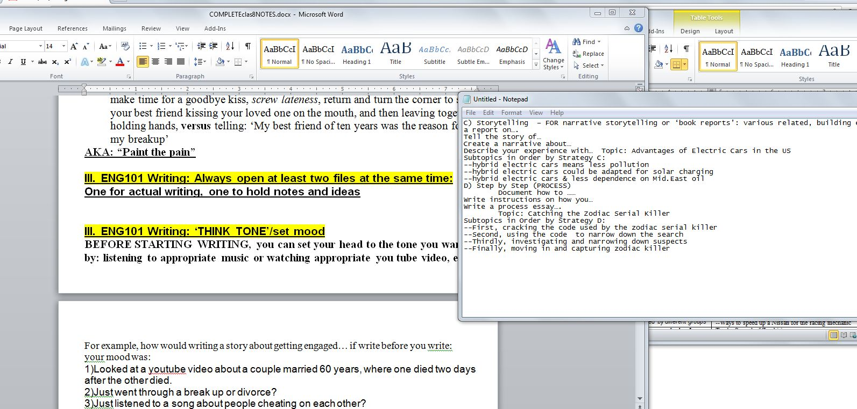

III. ENG101 Writing: ‘THINK TONE’/set and get into the right mood
BEFORE STARTING WRITING, you can set your head to the tone you want by: listening to appropriate music or watching appropriate you tube video, etc.

For example, how would writing a story about getting engaged… if write before you write:
your mood was:
1)Looked at a youtube video about a couple married 60 years, where one died two days after the other died.
2)Just went through a break up or divorce?
3)Just listened to a song about people cheating on each other?

IV. ENG101 Writing: Recovering from a pause or distraction
If you started but had to stop for more than a day or had a major distraction (good news, bad news, responsibility, job, etc) BEFORE STARTING again….
a)Read what you had or notes;
b)Rewrite or retype the last paragraph (small assignment) or last page (medium assignment) or last several pages (large assignment)
[COGNITIVE RE-ALIGNMENT]

V. ENG101 Writing: Organizing strategies (SEE HANDOUT)

Developing the FIRST DRAFT

II.A sample narrative example: “Eye on the Prize, Hand on the Ball” READ/Discuss
Note: the actual version, double spaced, is at least 4 pages!
What grade do you think this is headed to (still a draft)?
Strengths? Weaknesses?

“NARRATIVE EXPERIENCE THAT MAKES YOU UNIQUE:” [This is sample draft]

“Eye on the prize, Hand on the Ball” by Kurt Hesse
When people discover that I don’t have a thumb on my left hand, the first question they ask is, “How did that happen?” After telling my standard hand in the paper cutter joke to other teenagers or too much thumb-sucking to little kids, I tell them the honest reason for it: a birth defect. Sometimes they ask directly, sometimes you can just see the question in their eyes: how difficult my life must be, being the only shortstop on a baseball team -- without a thumb. I answer, “If you think that’s tough, my left thumb, check this out,” and then I show them my plastic right hand, and pop it off. The plastic hand creates shock, but that usually changes fast as soon as they see the familiar logo on the prosthetic. “Is that?....”
“It is.”
“Did you have that marked on there yourself?”
“Nope,” I answer. “Logo of my sponsor, and they designed this prosthetic specifically to allow me to play baseball, better. You have the sneakers; I got the hand – very limited edition.” I smile and this usually works as an icebreaker. Growing up, getting into sports in elementary school, at first, I used to feel cast out, different, wishful of just being ordinary. However, with a change of attitude, and a stroke of luck in finding a sponsor that went above and beyond, I usually convince most that actually, my difference is a uniqueness with value, teaching others by example the power of will…with a touch of technology and athlete friendly design, of course.

There are very few team activities which I cannot do because of my thumb or hand. I’m a lefty – whether I wanted to be one or not. The biggest “limit” of not having a thumb or a right hand has always been the minds of coaches, other players, scouts. However, to be honest, using just the standard Ott Bock prosthetic provided by insurance, I too knew I was good at my hobby, but a career in baseball? I’m a realist. I know, can see my limits on the team. This didn’t bother me because I made myself into a pretty good runner, letting teammates do the hands-on work, while I focused on running down people and being able to hit anything farther than most. However, once I tried out at the Nike “Play ball!” Open Call camp, it was clear that I was maxed out not in ability, but in action of what I could physically do. For whatever the reason, maxed out meant I could progress no further and my dreams of baseball as my everything had capped a lot short of sky’s the limit. I left camp feeling sometimes, giving all you can, still mean going nowhere. All those “we will make it through somehow” were Santa Claus lies – well meaning, but ultimately empty things that would not change who I was limited to be. I left camp feeling sorry for myself for the first time in my life. I didn’t play baseball for a month. Why partake if you can’t really win?
That’s when it all happened. That’s when someone from the company saw something in me that I was starting to, myself, disbelieve. That’s when a company known for athlete success decided to invest in me. I was called in, measurements taken, and a project explained to me. If I agreed, a designer hand, custom built and fitted for me, designed for baseball above all things. A team of twenty: engineers, prostheticists, trainers, analysts, and ergonomic/biomechanics experts. Almost a year of work. Twenty rounds of design and fittings. And cost to me? Nothing. Well, maybe my picture on a few ads.
My prosthetic right hand fits the bat the same way everytime. My left hand does take a few seconds more than most to finds a sweet spot, a position where I am able to shift and power the bat through the swing. I can feel the ball’s impact through the bat, through the prosthetic, and learned to take this feedback into training to better my swing, learn brute force how to him better than I ever could. Though at first some of my fellow athletes disbelieved in me and saw only my unique needs as a ‘cheat’ onto the team, eventually I got so good at running and hitting that the victories scored overcame any lingering resentment over changes in strategy and teamwork ideas. If my defense was still a weakness, my consistency at bat made that not matter a bit, or at least worth the risk of having me on the team. One year later: people now look with shock at my .650 batting before they see my hands. Every homerun I hit, I show off the logo on the front of my palm, and the crowd roars. The perfect tools in the hands of an athlete… my hand is that perfect tool.

I can say I’m unique rather than limited by my missing thumb and hand because of the standard ‘feel good’ self-empowerment answers: power of the human body to adapt to its surroundings, power of the will that doesn’t give up. That’s all good and well meaning. But it’s not just about being normal; it’s about being outstanding. Yes, I have become quite good at doing different tasks without a left hand thumb or right hand. Yes, there is absolutely no difference with typing this paper, because only one thumb is needed to press the space bar. I can hold a gallon of milk with my two middle fingers on one side, index finger on one side, and my little finger on the bottom -- something that as a child took me some work to master, but now is a reflex level adaptation. However, getting to the next level: that’s something that spirit can only take you so far. I’m proud of myself, but more so that a company (unasked!) saw beyond my disability and sponsored me in the sport that is always in my heart. Taking it to the next level isn’t just a slogan from the commercial. When you see this hand, when you see this logo, know one thing.
No Limits.
With the right tools and ambition, how can someone not succeed?
My name is Kurt Hesse, Tempe minor league MVP of 2010.

PRODUCT:
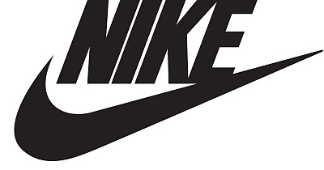JUST DO IT.

YOUR FIRST DRAFT WRITING, RECAP:
I. Remember to ‘show’ to the senses, not just ‘tell’. (describe with sense details as if to someone who can’t see – more dramatic and fills out more, too).
NOTE: Don’t overdo it: ‘the last lonely soggy brown seat on the bus smelled of decomposition and 3 day road kill rabbit killed by a filled to capacity port-o-potty during the Menudo and Tequila festival during stomach virus season, knocked over by high winds, dashed with a hint of end-of-construction-shift armpit, and topped off by the smell of unwashed P.F. Chang Arizona marathon runner’s ass on a 105 degree day with 85% humidity and a barometric dew point of 8.7, after a blitz day of that runner eating at the Menudo and Tequila festival during a full blown attack of the aforementioned in-season stomach virus …’
II. TWO FILES on your computer at the same time (computer two screens [notes to self and another for actual writing], or on paper, use highlighters or stick notes to write ‘notes to self’ as going along with actual writing
III. Get into a mood
IV. remind yourself of the mood if recovering from pause or distraction
V. Organizational Strategy if you need one.
VI. DON’T WORRY for a first draft:
1)spelling, grammar and punctuation
2)accuracy: correct names and complete researched details
3)handwriting/complete perfect paragraphs
4)symbol systems, image systems, and message levels
5)sparkling non repetitive word use & best scene order
6)filtering scenes and dialog for effectiveness or repetition

Now… 14 DAYS LEFT…Start writing…
FOR TUES NEXT CLASS:
Quiz #4: “For 9/18 T READ: “Facebook users ask who owns Information” 97-100
Hand in HW 5 (will be given out today)

END

Class10notes : examples from: http://www.bulwer-lytton.com/

Things to REMOVE from content drafts:
Adapted from http://www.du.edu/~mtursi/revising_fiction.html
1) preachy language [openly attack all bureaucracy by telling reader so, the ‘salvation’ purity effect]
2)remove clichés (dream sequence, ‘was a dark and stormy night’)
3) rewrite boring, non-descript main characters
6) things that would be impossible for a character to know The moment he laid eyes on the lifeless body of the nude socialite sprawled across the bathroom floor, Detective Leary knew she had committed suicide by grasping the cap on the tamper-proof bottle, pushing down and twisting while she kept her thumb firmly pressed against the spot the arrow pointed to, until she hit the exact spot where the tab clicks into place, allowing her to remove the cap and swallow the entire contents of the bottle, thus ending her life.
7) bland or repetitive language [avoid just using he said, she said, very often
9)The sun, setting, meant the end to a sunny day, and the beginning of darkening night until the sun rose again at sunrise. ]
8) inappropriate imagery [‘turned up her nose like unluckily catching a whiff of her own flatulence’] [from Throw Momma Off the Train: ‘Mrs. Hazeltine: [reading her manuscript] His guts oozed nice, like melted malted icecream.’]
9) Too complex, too much detail, over the top language – especially in the middle of action or conflict.
Gripping his six-shot Colt Python with 8-inch barrel and Royal Blue finish, and tightening the straps on his Paratec Speed 2000 parachute, Jake leaped from the left aft hatchway of the tumbling, green-and-silver, twin-engined Embraer Lineage 1000, which had seating for nineteen passengers.

Example 2: The victim said her attacker was 5' 10 and 3/4", 163 pounds, with Clairol #83N hair (a hint of #84N at his temples) -- and last seen wearing Acuvue2 contacts, a white Hanes 65/35% poly-cotton t-shirt with a 3mm round Grey Poupon stain on the neckband, Levi's 501s missing the second button, and Nike Crosstrainers with muddy aglets
10) confusing sentence [anguished English example] There would be jail time for the tomato throwers, while the Enron executive with his 12 lawyers and only slightly tomato-stained conscience would be released to celebrate festively with thousand-dollar bottles of champagne, an affront that would be less worse than the fates of thousands: the thousands of now unemployed forced to stand in line for free government cheese for the next years of their lives, frozen ghosts in line forever -- that is -- if the vines of their lives did not yield a more bitter fruit, meaning, of course, the cases of the thousands of despairing apparitions born of hundreds of suicides, suicides that would most likely happen so sadly on broken hearted Christmases without gifts, Turkey, or even, cold, ungarnished, one bean salads.
11) too blatant & obvious symbolism [crime partner named Judas, etc]
12) pretentious or over precious language (‘perpetual peregrinator’ when you can just say ‘jogger’ A single sparkling tear fell from Little Mary's cheek onto the sidewalk, then slid into the storm drain, there to join in its course the mighty waters of the Los Angeles River and, eventually, Long Beach Harbor, with its state-of-the-art container-freight processing facilities.
13) Bizarre or too private a reference
14) gratuitous violence or sex or language [allude to ‘F’ word, “She poured acid into his eyeballs, quick drying cement into his nose, and hand sewed his lips shut. Then she decided to begin to torture him]
15) a neat “bow tie” conclusion [And the secret stranger came in just in time, knocked the gun out of the criminal’s hand, and said, she doesn’t know this, but I’m not just a secret stranger. I’m her father, and I trained as a Kung Fu master, so now, prepare to fight me to the death and lose!”]

understanding chinese culture

understanding japanese society

understanding australian students

cultural differences germany america

cultural differences iran america

