CLASS 4: 7 steps of Writing Effectively:
focus: American AUDIENCE

READING FOR TODAY’S QUIZ 1
Should companies be required to immediately report customer hacks?
http://www.scu.edu/r/ethics-center/ethicsblog/business-ethics-news/15517/CYBER-ATTACKS:-Should-Companies-Admit-They've-Been-Hacked?
(on a piece of paper w/name or email)

QUIZ 1 question: Choose a side (‘report immediately’ or ‘delay until legal dept input’) for reporting company hacks. List 3 reasons to support your side.

TUES Quiz 2: READ: NEW VENTURES:
8 Absolutely No Bullshit Things Every Entrepreneur Should Know
READ : https://exversiondata.wordpress.com/2015/01/28/8-absolutely-no-bullshit-things-every-entrepreneur-should-know/

HOW quizzes are graded: 0-10 pts (magic number = 80)
10: DETAILED answer with supporting quote(s) or example(s) from reading
9: Detailed, but 1 weak part / not best quote or example
8: OKAY detail, but weak or no quote
6-7: It could be written by someone without reading/referencing article

REMINDER: 19/25 students go to Career Services + selfie (1 so far) by NEXT THURSDAY to reduce to 7/8 arguments in final research paper

I)Discuss HW 1 results / Collect HW 1

II)What are the 7 steps ANY piece of public writing must go through before presenting?
I. Prewriting: PARTS +Audience (Audience, timing, 10 tools/ tones of appeal, etc)
II. Brainstorming content/ outline or notes, googling, research

III. starter draft/ zero draft (purpose)

IV. first draft

V. Revising [for content] drafts

VI. Proofreading [for errors]

VII. S.olution/Final Draft/Presentation

III)American AUDIENCE issues are IMPT when figuring out the Problem and the Analysis of P.A.R.T.S. of a solution

1)AUDIENCE: are you writing/presenting/marketing like a diary, only for yourself? If not, you have an audience. Question to ask about AUDIENCE as you start to work past ‘P’ of PARTS BUT ALWAYS BEFORE Planning or writing:
(A) What is your main audience? What kind of things do they want to read/ see that establishes your purpose (entertain, anger, persuade, sell, etc)?
(B)Do your topics and general tone match that audience and your purpose or do they ‘turn off’ or offend?
(C)Can you narrate, write, your specific experience or a product in a way that has strong appeal to your target audience, but enough cross-over value for a general audience?
(D)Are there any cultural differences that don’t translate or taboos that will create issues/change the mood of how they receive your purpose/message?
[to be address in OCT : GLOBAL AUDIENCE]

Why profile an audience?: avoid unnecessary work, goals, solution dead ends, inappropriate language/images, examples inappropriate for intended audience

American AUDIENCE centered SCENARIO:
Problem: sell a car.
PROBLEM w/AUDIENCE: How do you target the middle class population now in their 30’s -40’s (minivan dads & soccer moms) with kids, that grew up with pop hip hop and want to think of themselves as ‘the cool parents’, when you are selling minivans…
https://www.youtube.com/watch?v=pUG3Z8Hxa5I

Hand Gestures, auto tune, etc…
What hip hop tropes did they research?
--- what did they do to reach the specific audience demographic? Images? Music? Words/lyrics? Actors? Humor?

Did they get those right?
--What would car product be for 17-24 year olds? What would change about the commercial?
Images? Music? Words/lyrics? Actors? Humor?

Do you think the Solution (The Swagger Wagon video) of PARTS + Audience (Presentation) above was successful analysis of the Problem – meaning hitting primarily the target audience (30-40’s) “without alienating ancillary demographics” (younger or older minivan buyers and riders)? Why / Why not?

STEP 1: Attention to your main audience

**Attention to audience CAN change how you choose and analyze your topic choice, your words, and your images**

How would a presentation/ biographical INTRO be different if your audience were
Hire you for an office job
Just students (and they vote on your grade)
People who are raising money to give you a scholarship
People who believe college is a waste of money
People in a skate park

TIMING CAN ALSO CHANGE YOUR CHOICE/ANALYSIS/IMPACT:
BELOW: Even if the first is less violent than the second….
What audience concerns got the first banned in the US (by Xbox marketing) since the theater shooting, while the second was not?

Xbox fake shooting commercial (was banned): http://www.youtube.com/watch?v=3ZcNXe20dXI

Vs Call of Duty Black ops Commercial:
Primary audience is? Crossover audience by which method?
http://www.youtube.com/watch?v=Pblj3JHF-Jo

STEP 2: Hooking GENERAL Audience Appeal

PLANNING FOR ALL AUDIENCES
ALL cultures, within their society’s norms, have about 10 marketing or persuasive approaches – tools or categories of how to tell story (tone), of choosing topics for writing, towards hooking an audience’s attention.

If you re-write or punch up or adapt your specific ‘story’ (fiction, product commercial, political ad, etc) in one of these 10 tones, you hook a general audience more easily and can translate to same audience in a different culture more easily

Every culture defines each of these 10 attention-getting hooks/approaches differently (what is merely controversial in one culture (Janet Jackson exposed breasts during Superbowl), is punishable by jail in another (In India, an actress returning to her rural village was nearly set fire for a movie where she showed her breasts in a honeymoon movie scene) is boring in another (almost every beach in Spain is topless optional).

TONE and SPOKESPEOPLE: WHAT CAN YOU CHANGE ABOUT YOUR WRITING to match different audiences
10 Universal TOOLS (or themes) in telling story/choosing topics
to hook General audience appeal
(different for each culture, may not translate between different cultures, but every culture has these ‘hooks’ for attention)
1)Universal ‘human’ drama : tragedy, drama, family, loneliness, etc

2)Fantasy roleplay (eg Axe Spray, Sports Videogames)
3)Ride or react to a Trend (eg Vampire genre)
4)FEAR

5) Celebrity or sexual or heroic character’s endorsement (“Be Like Mike”, Japan’s Ronald McDonald: http://youtu.be/_UKLncvGxQ8 )

6)Humor

7)Desire to be successful /cool

8)Intensity

9)Disarming of a Fear

10)Over the top or Controversial
END

Today…Collect HW 2: career skills
I. DiscussSample and actual Analysis Breakdown project + Career Analysis short Personal Essay (100 pts):
II. AUDIENCE APPEAL as part of the Problem and Analysis in P.A.R.T.S. of a solution
HW 3: due next class
Next class: More STEP 2 of Writing Effective: Audience + Global Audience/other cultures

http://withoutbullshit.com/blog/you-should-write-like-larry-page-in-his-google-alphabet-announcement/
The press release, as a tool to generate media coverage, is dead. It has been for long time. As the amount of content the media generates daily has increased, the number of paid professionals producing that content has decreased. When a newspaper like the New York Times lays off 1500 staffers over 10 years, who do you think is left to read the 500-plus press releases they receive each day? Good media relations starts and ends with a simple, straightforward pitch with content to support it. Larry Page accomplishes it with a blog post -- though, it's not like there was any chance in hell that the media wasn't going to cover this story. However, Page has provided strong context that has helped them understand it better.

Also their culture is around efficient simplicity, which cascades to the announcement style.

Since they have the best staff, chances are they read you.

you can hire the best possible professionals to obscure the truth, or those who excel at revealing it. The culture comes from the top.

I'll be the token contrarian here, since I have ghost written for many CEOs over the years, including a couple of very big names. Ghost writing is somewhat like improvisational acting, in that the writer must take on the voice of the person for whom he or she is ghosting and write in the same style that they speak. The greatest compliment is when people make that very same statement "sure sounds like authentic writing from the CEO to me." I do this for a living, and I can say with authority that some of the most "authentic" speeches from business leaders -- even oft-quoted ones -- have been ghosted for them. That's the point of it, to make someone sound incredibly articulate AND authentic at the same time. I'm not saying Page didn't write his own post, but given the stakes of the announcement and the nature of Google as a publicly traded company, I'd bet every dime in my pocket that Page at least had help on that blog. With the stakes so high, I doubt a smart CEO would post something of that gravity without seeking counsel from some of the best marketing communications pros in the world
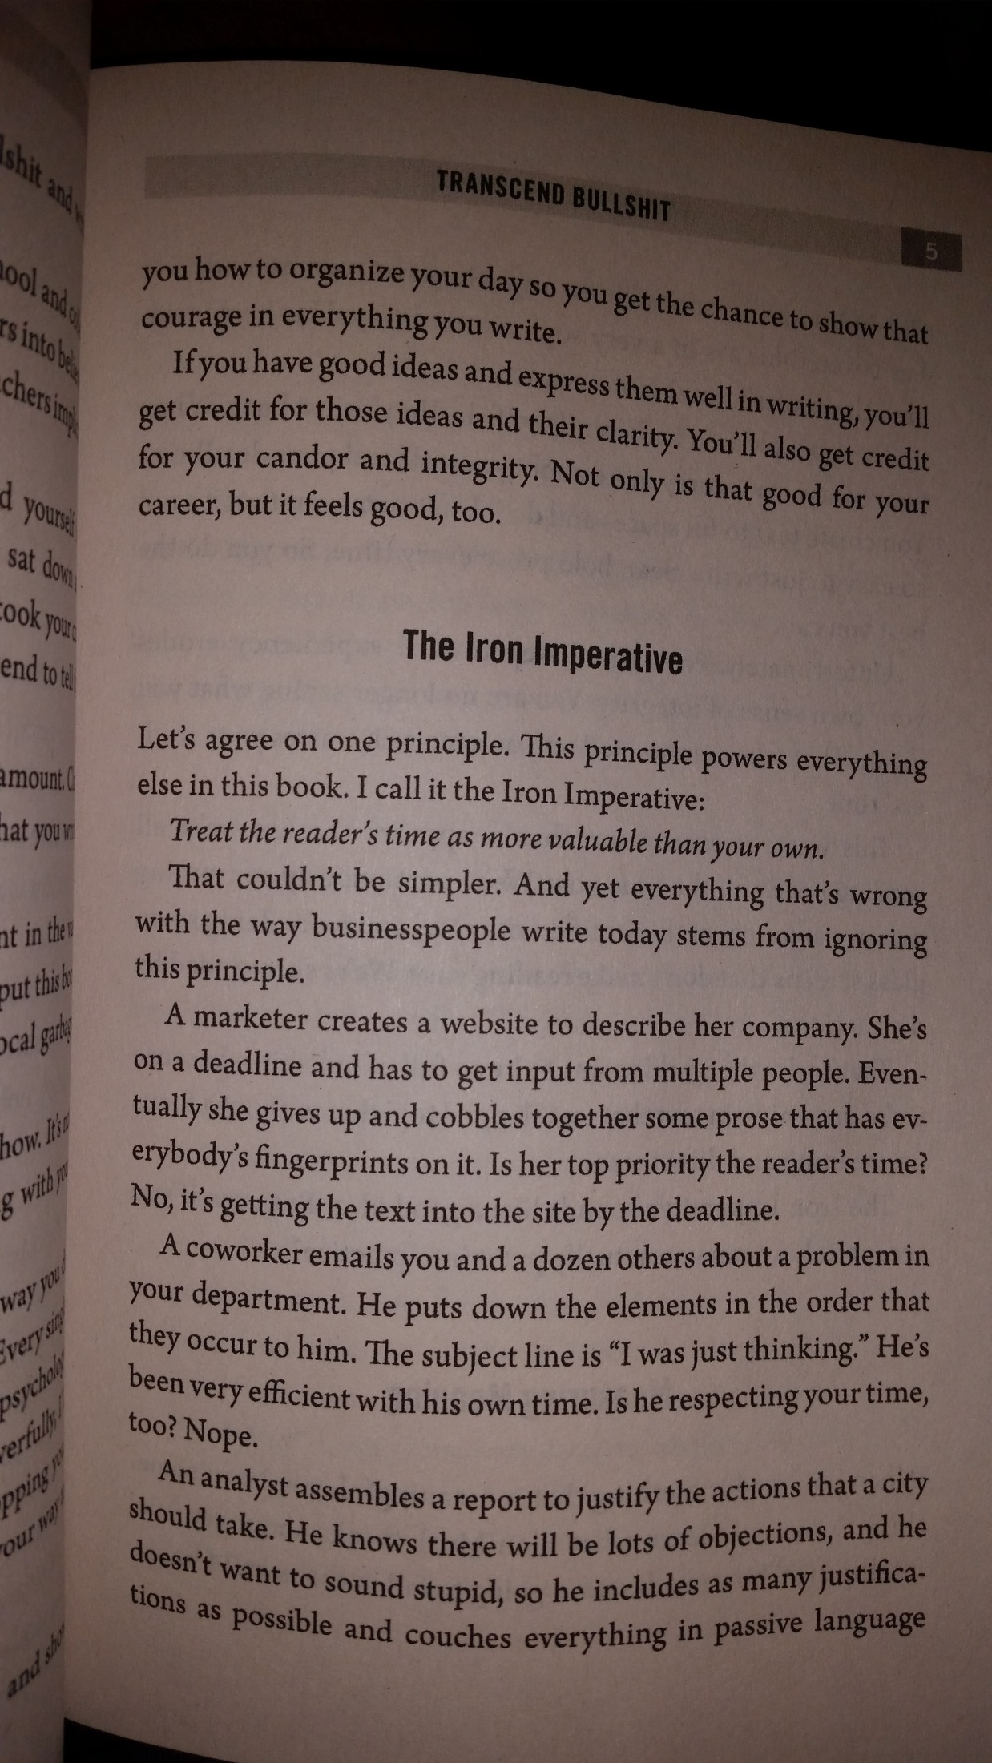
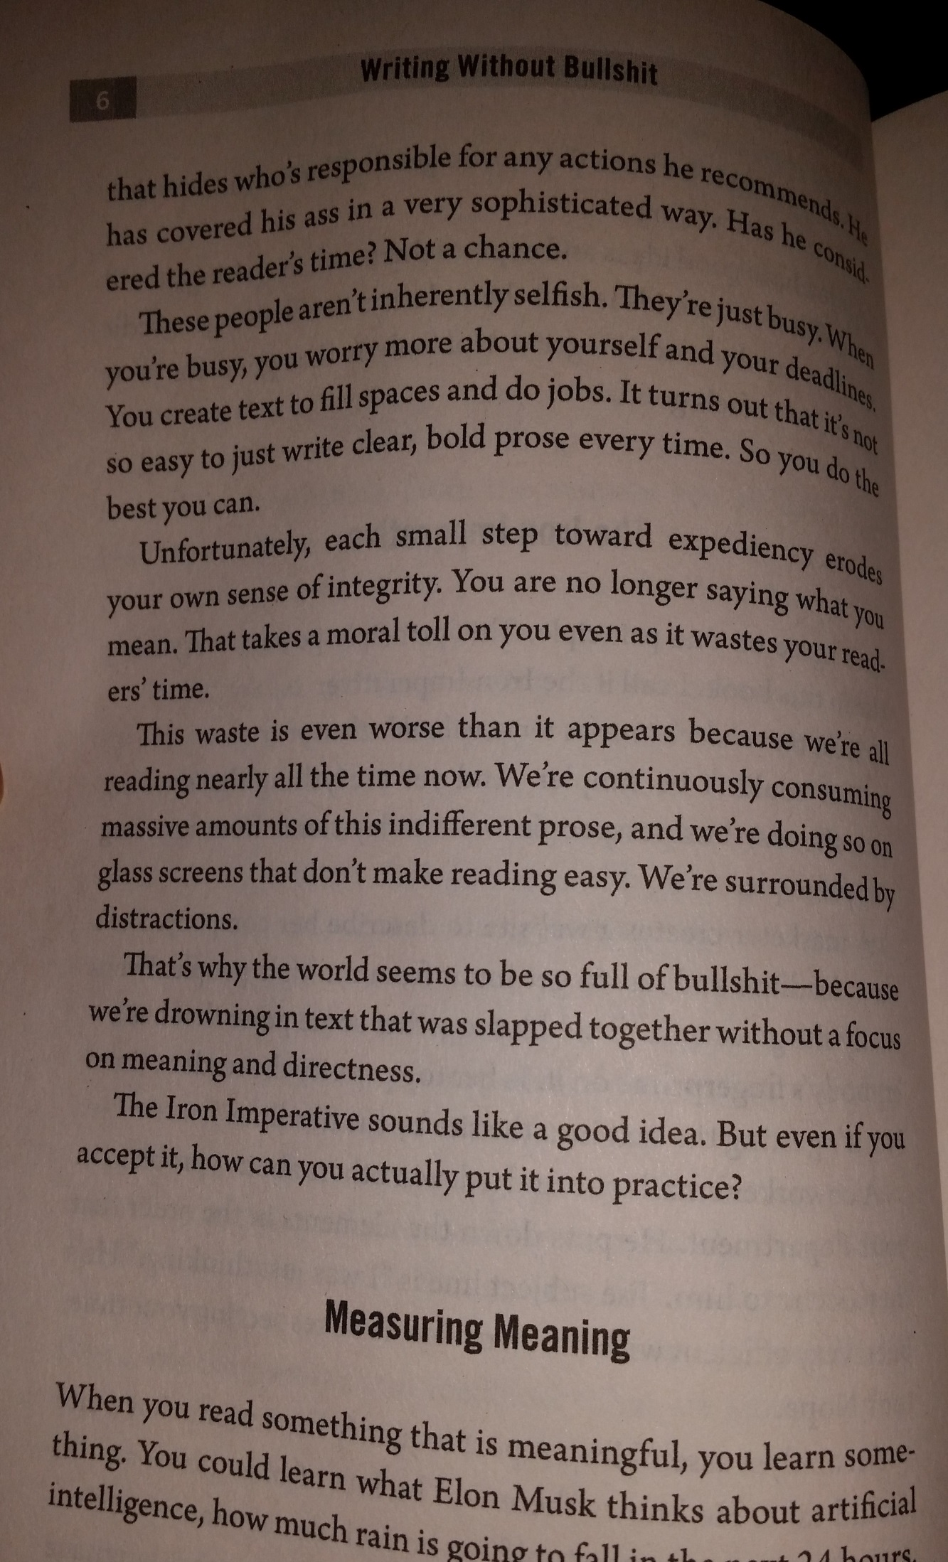
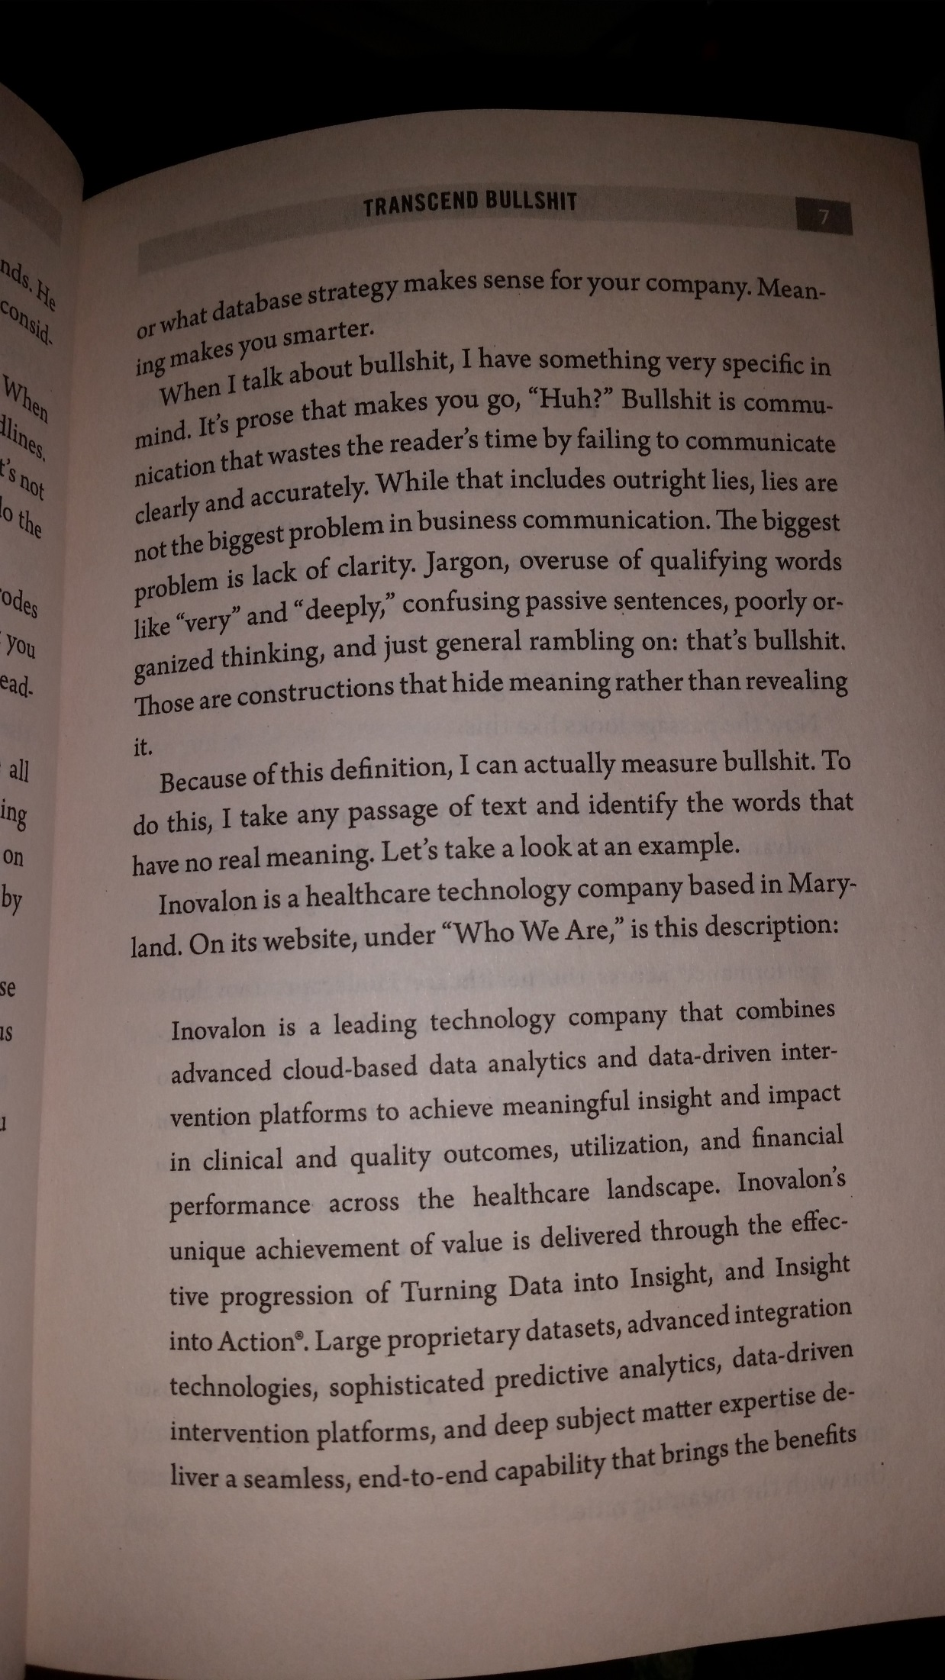
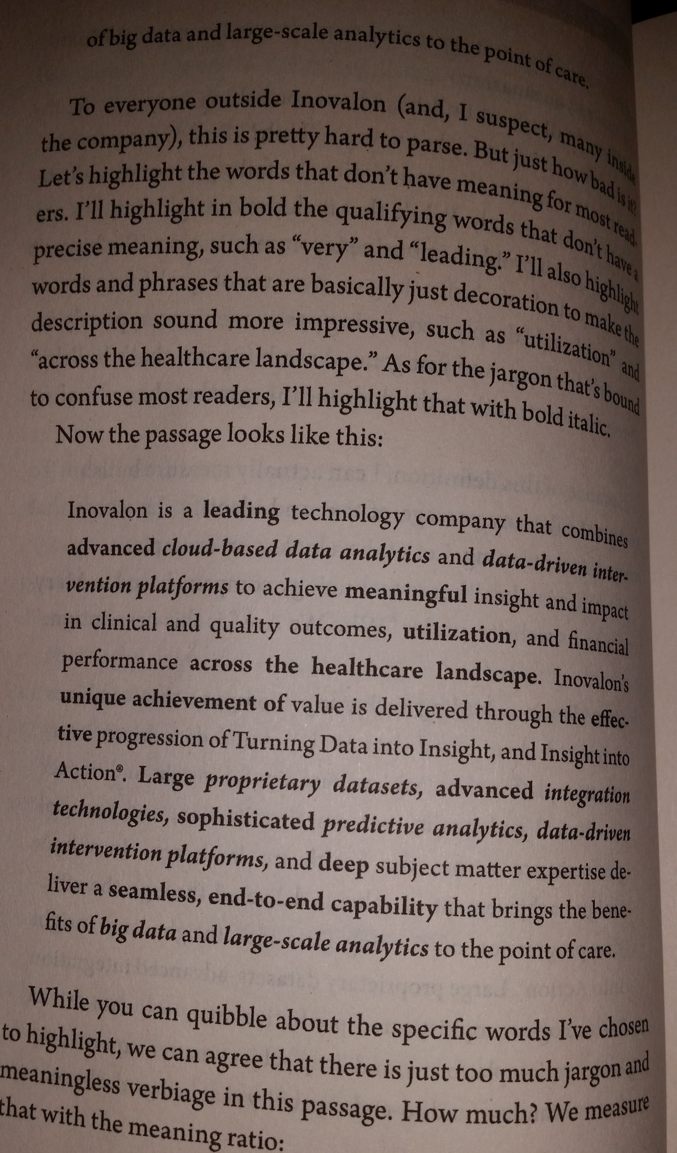
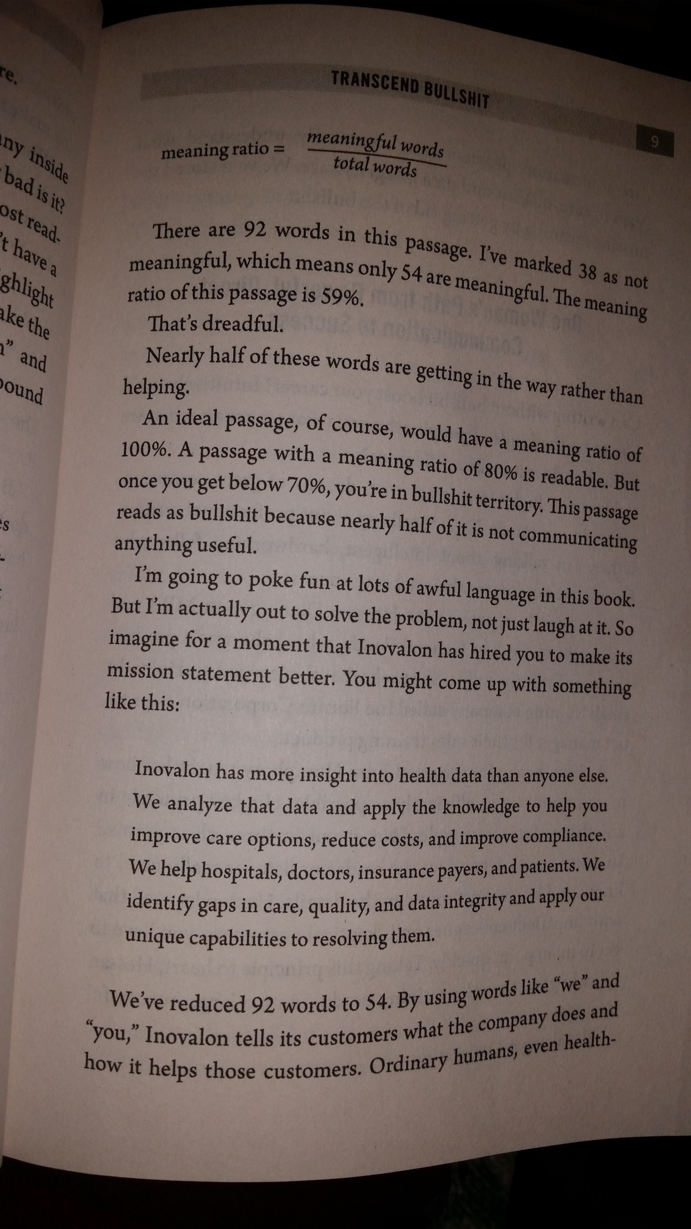
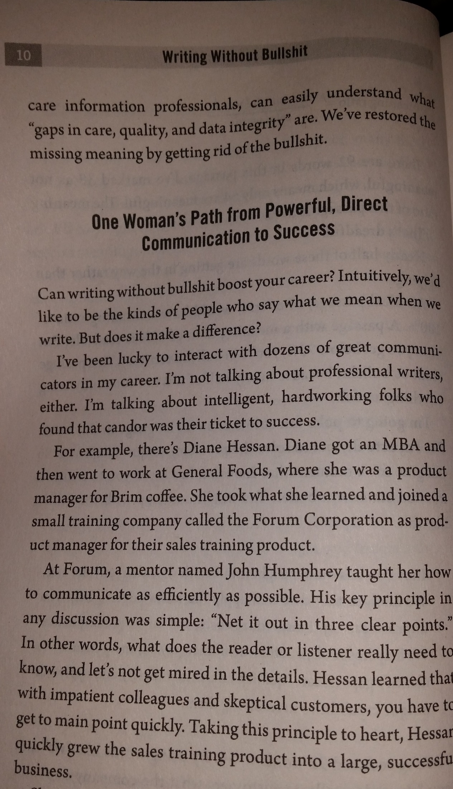

GLOBAL AUDIENCES (FOR OCT 6)
What happens when a commercial’s audience doesn’t translate?
EXAMPLE:
Problem: Korean company sell American style Fried Chicken Batter in Korea
Wrong Analysis/Wrong Solution: Our Fried Chicken batter mix commercial is American hip! Everyone wants to be American hip!
Audience: Hip Korean moms & kids who want American style chicken
Research: American style is….
Happy Family meal
American slang from hip hop movies!
Science Fiction!
Research: Every hip American says “What the Hell!” “and Yo” like “Yo MTV raps”
??Catch phrase sounds like: "What the Hell? Fried Chicken!"
Catch phrase: "Yo, I'm about to eat!"
SOLUTION:/PRESENTATION/AD:
http://youtu.be/7pOoSe2K5DU

Successful in Korea, in 80’s. Would it work in the U.S. Would you buy “What the Hell Fried Chicken Batter”?

We will revisit CULTURE DIFFERENCES when we do COMPARE/CONTRAST
But now for its relevance on your own active writing….
Part of the American college experience is interacting with, writing for a diverse ‘globalized’ audience – socio-economically, politically, ethnically, etc. You will have a mixed classroom/mixed audience from now on for papers, essays, presentations. Welcome to college.
So you will write honest stories and have opinions, but you also have to understand you will need to appeal to a general audience this means when you write stories (fiction or narrative non-fiction) you should try to get in/consider at least 3 of the ten Tools/TONES/hooks for a general audience. When you peer review, you need to answer what’s asked, not what you believe.

FAILS TO TRANSLATE because the ten tools were not used for American Audiences:

#1What prevents this Japanese commercial (Dole Bananas) from translating to American audiences (for selling Bananas):
http://www.youtube.com/watch?NR=1&v=dpqxSBclqWs
What fails here to work for U.S.A?

#2: Tea for High Blood Pressure http://www.youtube.com/watch?v=Q0r6LfjMYRE
What fails here to work for U.S.A?

Which of the ten approaches/appeals are in effect in this commercial:
You can combo tones for added effect:
Which are in effect?
Magnavolt Car Alarm: http://www.youtube.com/watch?v=w39o6eSI06Y

Would it work in PC America?

ACTIVITY: EXAMPLES of cross-over appeal to general audience without sell-out: How do these do it (or fail to do so) – Which of the 10 audience ‘appeal’ tools/techniques are in play?

I want more time: http://www.youtube.com/embed/UvYb4BLIAQw

HW 4: FOR NEXT CLASS: AUDIENCE LOST OR FOUND IN TRANSLATION
ENG 101 HW 3: ON A PIECE OF PAPER or BY EMAIL: Due: ____
HW 3: AUDIENCE LOST OR FOUND IN TRANSLATION
(answer on a separate paper or email..)
1a)Find one American commercial on youtube etc that you think would translate ‘as is’ into most countries’ culture. Print/enter its http address.
1b)Why do you think it would translate to a general global audience?

2a)Find a commercial from another country that you feel does NOT translate for an American audience. Print/enter its http address.

2b)Why do you feel it succeeds in that culture’s audience, but NOT to a general (US) audience?

2c)Choose one Universal storytelling tool below. Write in a few sentences how you would change the commercial to specifically use the crossover tool (FEAR, humor, etc) for a US general audience.

2d)Why do you think your change would make it work for American audiences?

10 Universal TOOLS in telling story/choosing topics
to hook General audience appeal
(different for each culture, may not translate between different cultures, but every culture has these ‘hooks’ for attention)
1)Universal ‘human’ drama : tragedy, drama, family, loneliness, etc

2)Fantasy roleplay (eg Axe Spray, Sports Videogames)
3)Ride or react to a Trend (eg Vampire genre)
4)FEAR
5)Celebrity or sexual or heroic character’s endorsement
6)Humor
7)Desire to be successful /cool
8)Intensity
9)Disarming of a Fear
10)Over the top or Controversial

Next class: Read for quiz question #1: “Student loan Scandal” 46-57

